**Challenge 2: Detective SQL**

**Key Points**:

* Retrieving the corresponding crime scene report from the police department’s database.
* Figure out who committed the crime.

**Answer:**

The Answer is “***Miranda Priestly***” who was the real villain, while ***“Jeremy Bowers”***  committed the murder. But here is my thought process;

* Firstly, since I vaguely remember some information, which will be used to search out the crime scene report, I went ahead to use this query to get the information i needed.

***SELECT * FROM crime_scene_report WHERE date = 20180115 AND city= "SQL City";***

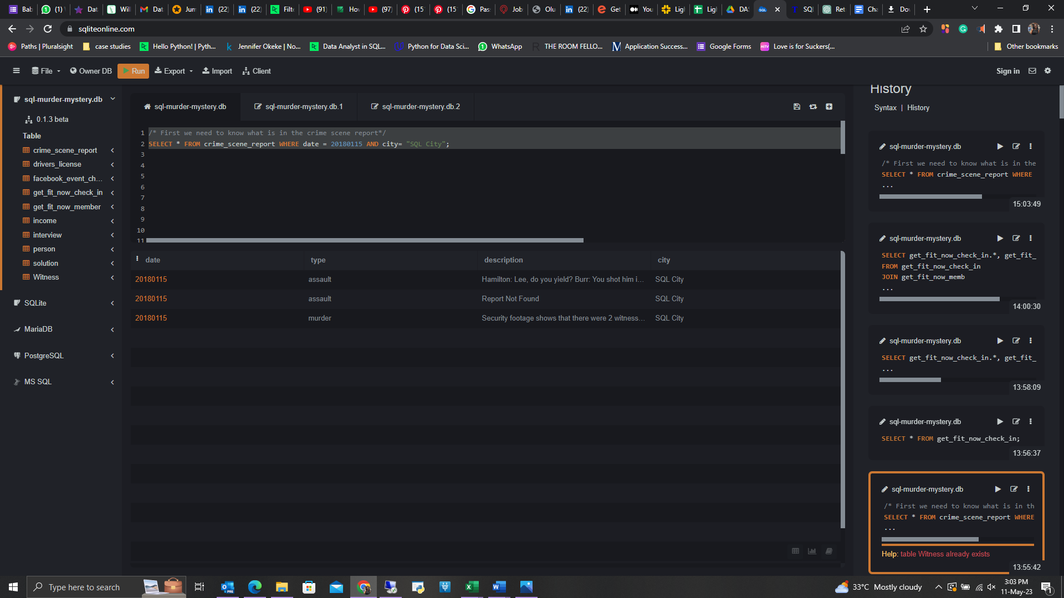

From that I could pick the third one because type was murder and it is a murder case.

* From the report I was able to see that I had two witness, one name unknown but lives at the last house on Northwestern Dr and the other having Annabel in the name but lives somewhere at Frankline Ave.
* I have to know the name of the first witness. Hence, this query;

**SELECT * FROM person WHERE address_street_name = 'Northwestern Dr' ORDER BY address_number DESC**;

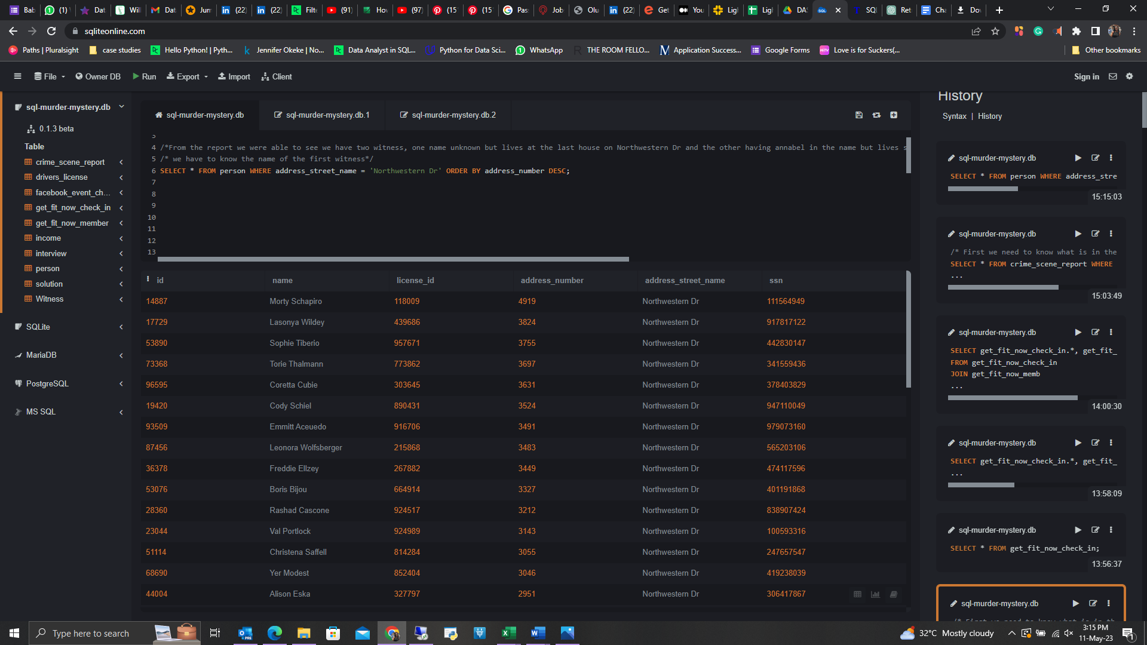

* From here, I can see that ***Morty Schapiro*** is the first witness, now I go ahead to know the second witness who has Annabell in her name and lives somewhere in Franklin Ave.

***SELECT * FROM person WHERE name LIKE 'Annabel%' AND address_street_name = 'Franklin Ave' ORDER BY name;***

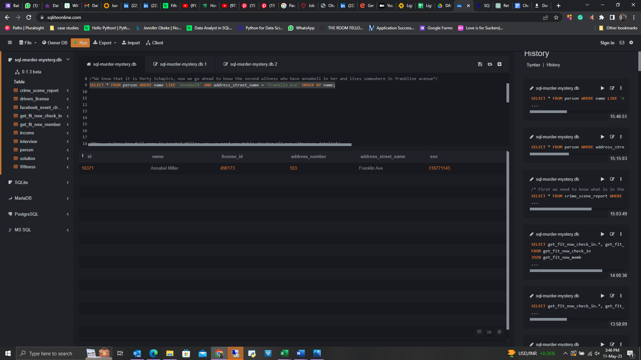

* Now, I know her full name is ***Annabel Miller***, now I need one table showing all our witnesses details and also to save it as a table-Witness for future reference.

***CREATE TABLE Witness AS SELECT * FROM person WHERE address_street_name = 'Northwestern Dr' AND name = 'Morty Schapiro'***

***UNION***

***SELECT * FROM person WHERE name ='Annabel Miller' AND address_street_name = 'Franklin Ave';***

* checking our new table.

***SELECT * FROM Witness;***

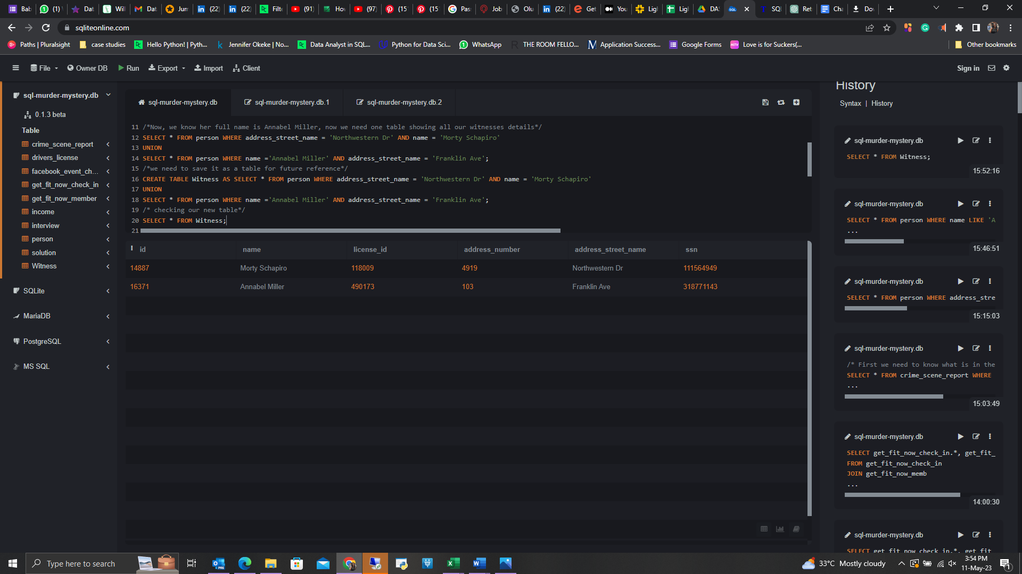

* So the new witness table connects to the interview table, so I can know what was said during their cross examination to have a hit on who the murder is, by performing a JOIN.

***SELECT Witness.*, interview.transcript FROM Witness INNER JOIN interview ON Witness.id = interview.person_id;***

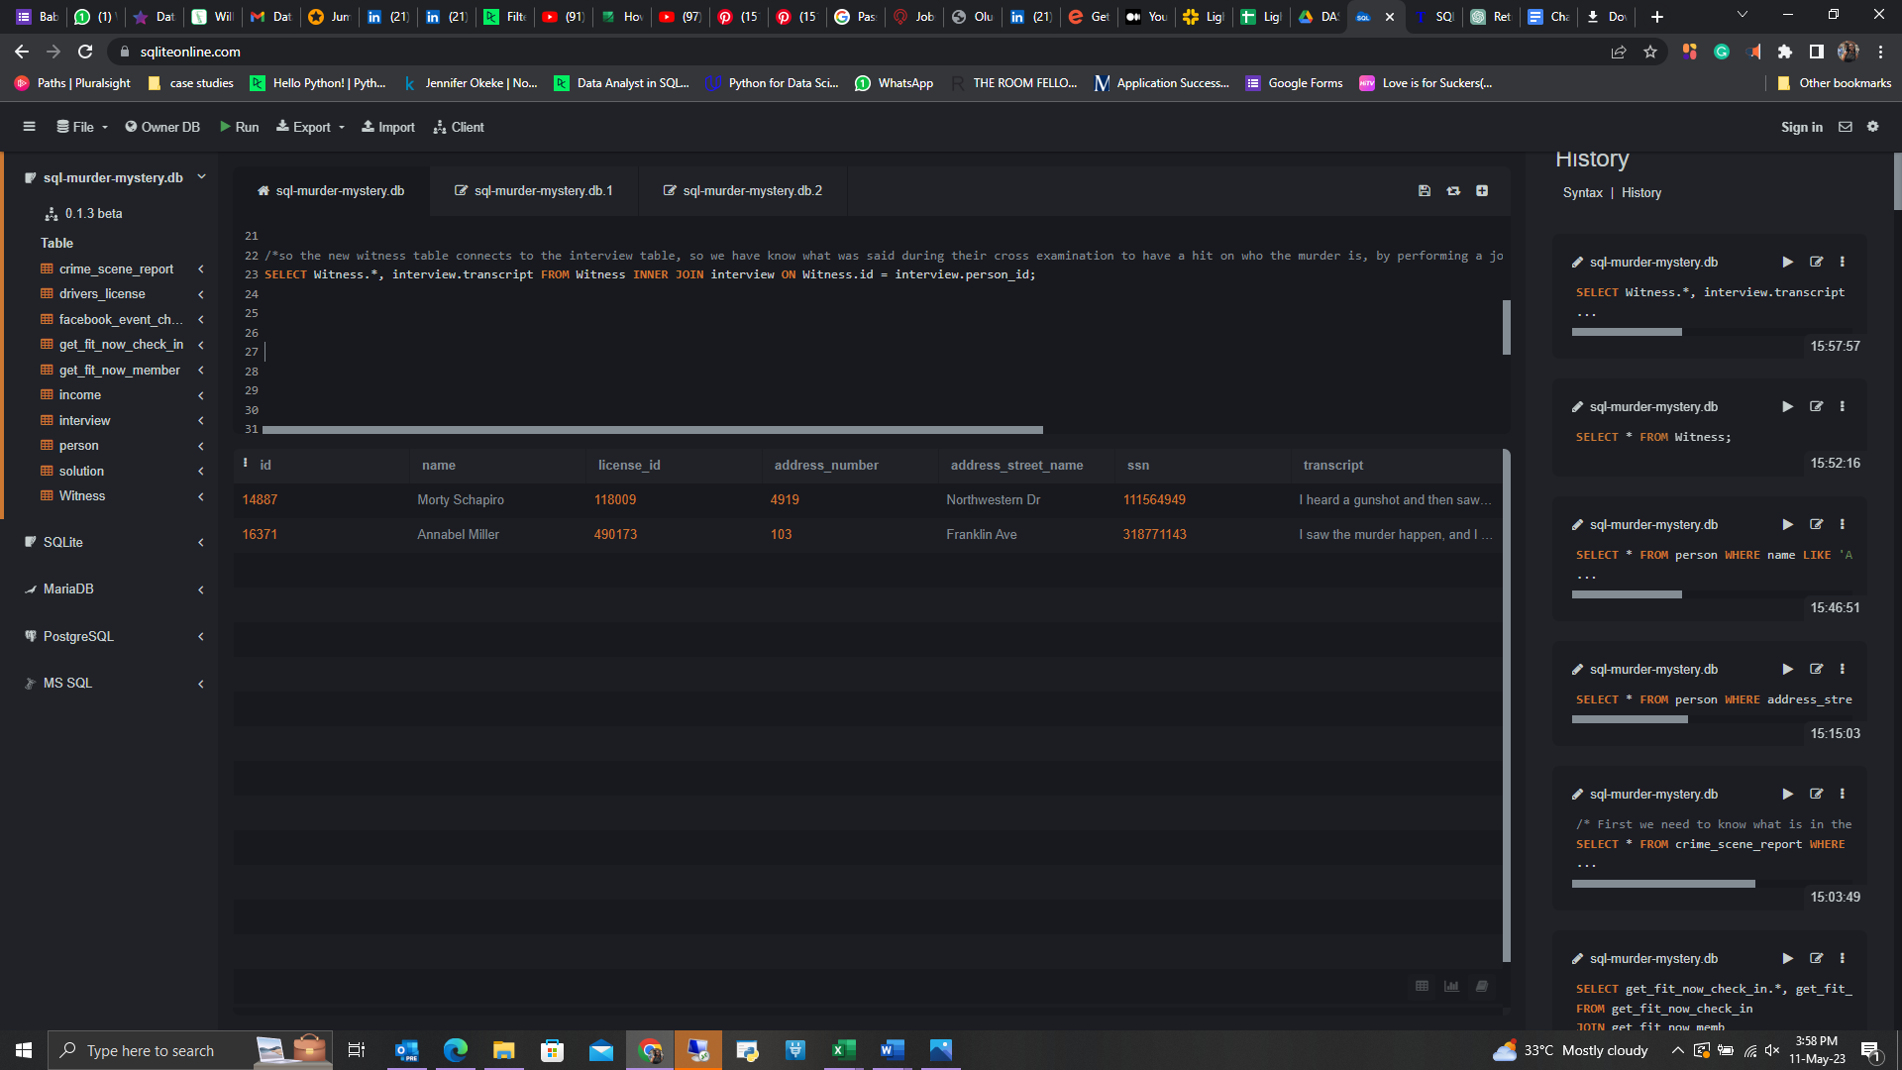

* Based on their testimony, I have to get data and see whether what they said match.
* Morty said from the transcript column- “*I heard a gunshot and then saw a man run out. He had a "****Get Fit Now Gym****" bag. The membership number on the bag* ***started with "48Z"****. Only* ***gold members*** *have those bags. The man got into a car with* ***a plate that included "H42W"****.* All the text highlighted will serve as a clue on what to do next therefore I will look for this info from the get_fit_now_member, driverdrivers_license and person tables.

***SELECT get_fit_now_member.*, drivers_license.id, drivers_license.plate_number,drivers_license.car_make, drivers_license.car_model***

***FROM get_fit_now_member***

***JOIN person ON get_fit_now_member.person_id = person.id***

***JOIN drivers_license ON drivers_license.id = person.license_id***

***WHERE drivers_license.plate_number LIKE '%H42W%';***

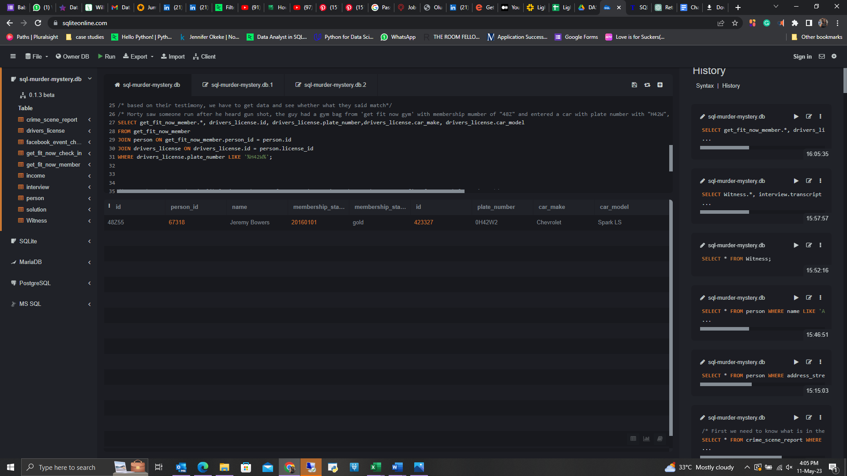

* Now I know the murder is likely ***Jeremy Bowers*** from Morty's testimony but I have to confirm from Annabel testimony as well.
* Annabel said *“I* ***saw the murder happen****, and I* ***recognized the killer from my gym*** *when I was working out* ***last week on January the 9th.****”* This states that she saw the murder happen and it is the same person from her gym where she worked out on the 9th of january, the previous week before the murder. I just need to check the get_fit_now_member and get_fit_now_check_in tables to be sure that her testimony aligns with what she said, also what Morty said as well will lead me to the murder.

***SELECT get_fit_now_check_in.*, get_fit_now_member.\****

***FROM get_fit_now_check_in***

***JOIN get_fit_now_member***

***ON get_fit_now_check_in.membership_id = get_fit_now_member.id***

***where get_fit_now_check_in.check_in_date = 20180109;***

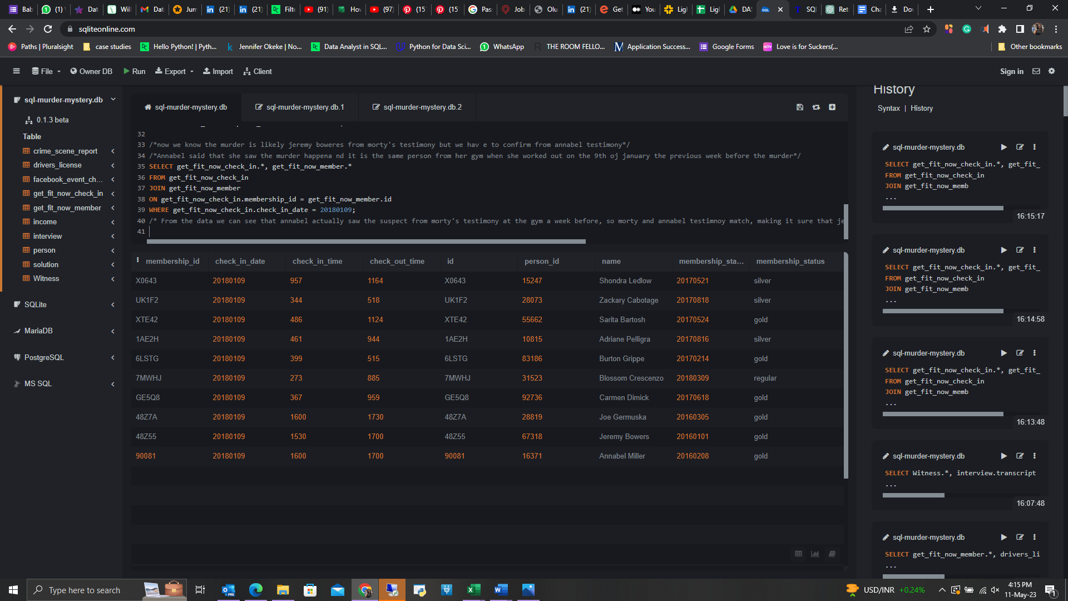

* From the data we can see that Annabel actually saw the suspect from Morty's testimony at the gym a week before, so Morty and Annabel testimony match, making it sure that ***Jeremy Bowers*** committed the murder.
* Now we need to know who instigated the murder- the real villian. I went to the solution table and discovered there was a trigger, which had a clue.

***INSERT INTO solution (user, value) VALUES (1, 'Jeremy Bowers');***

***SELECT value FROM solution;***

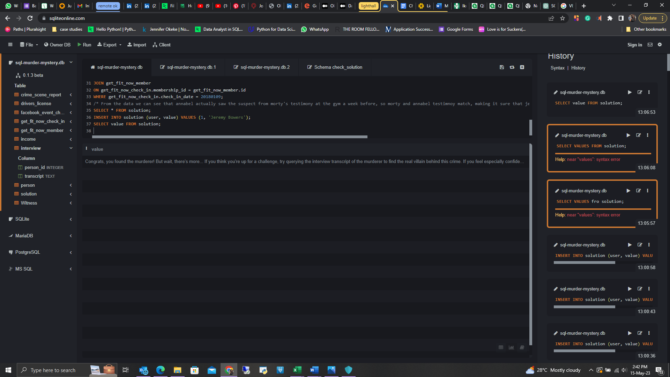

* *“Congrats, you found the murderer! But wait, there's more... If you think you're up for a challenge, try querying the interview transcript of the murderer to find the real villain behind this crime. If you feel especially confident in your SQL skills, try to complete this final step with no more than 2 queries. Use this same INSERT statement with your new suspect to check your answer.”*
* After querying the interview table , i fouhnd more clues, jeremy bowers said *“I was hired by a woman with a lot of money. I don't know her name but I know* ***she's around 5'5" (65") or 5'7" (67")****. She has* ***red hair*** *and she* ***drives a Tesla Model S****. I know that she attended the* ***SQL Symphony Concert*** *3 times in* ***December 2017****.”*

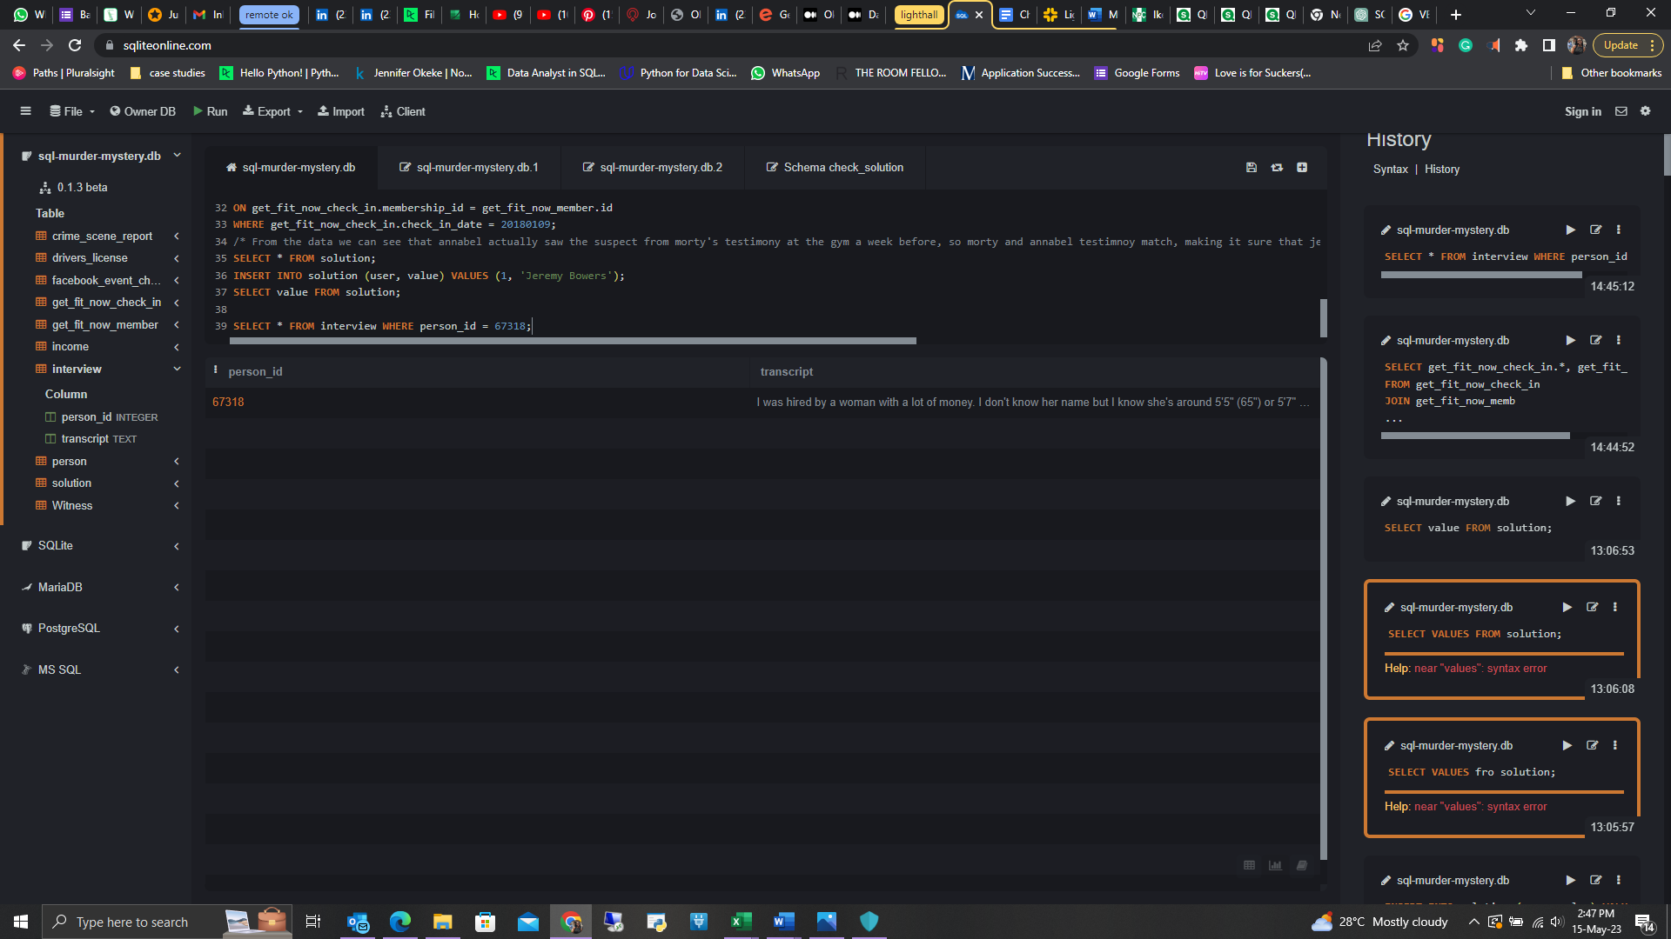

* I used those clues to find out that the real villain is “***Miranda Priestly”*** with the query below*;*

***SELECT facebook_event_checkin.*, drivers_license.*, person.name***

***FROM facebook_event_checkin***

***JOIN person ON facebook_event_checkin.person_id = person.id***

***JOIN drivers_license ON drivers_license.id = person.license_id***

***WHERE facebook_event_checkin.event_name ='SQL Symphony Concert'***

***AND facebook_event_checkin.date like '201712%'***

***AND drivers_license.hair_color = 'red'***

***AND drivers_license.car_make= 'Tesla'***

***AND drivers_license.car_model= 'Model S';***

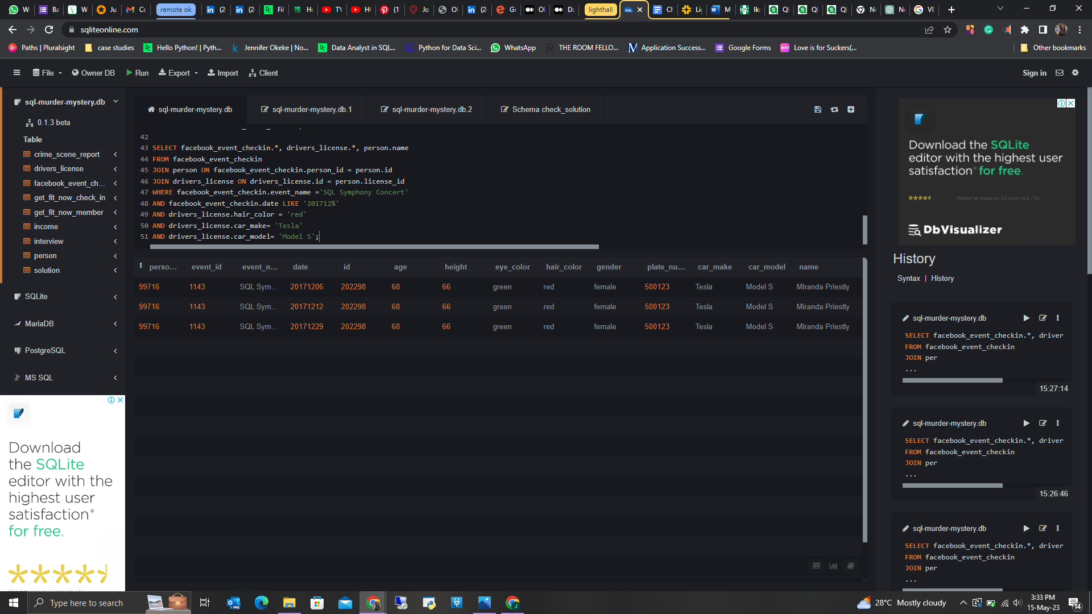

* Now to check if I am correct, I need to go back to the solution table.

***INSERT INTO solution (user, value) VALUES (1, 'Miranda Priestly');***

***SELECT value FROM solution;***

